**AMRITA VISHWA VIDYAPEETHAM**



**19CSE101**:Computer System Essentials

**Topic:** Library Management System

**Group members** :

R.ABHINAV (CB.EN.U4CSE19453)

P.KOUSHIK (CB.EN.U4CSE19449)

N.KARTHIK (CB.EN.U4CSE19444)

**ABSTRACT**

Library is a place where all kind of books are available . library management system is a web based application. This web application is used for monitoring and controlling the transactions in the library.the system contains list of all the books and can be accessed by remote users concurrently from any where in the campus. But for that users must be registered user.

Users can search for books and renewal books online. They can view the issue and return dates of any book and due they have to pay.the project design focuses on making the system secure and easy usage to all .

**KEY WORDS** :

Web based application , secure ,remote users.

**DECLARATION**

We hereby declare that our report under the title “Design a database” being submitted as a computer system essential project to the department of computer science is a genuine work under the guidance of, **Dr.J.GOVINDARAJAN**, assistant professor in the Department of computer science, Amrita Vishwa Vidyapeetham, Coimbatore

Signature of the faculty

**Name: signature:**

R.ABHINAV (CB.EN.U4CSE19453)

P.KOUSHIK (CB.EN.U4CSE19449)

N.KARTHIK (CB.EN.U4CSE19444)

**OPERATING SYSTEM - OS**

**ANDROID**

Our team has chosen Android because now a days it is the most used mobile os in the whole world. Our android application is used to search books, book review, reserve and return books etc.

The android os is derived from Linux kernel 2.6 and compiled for electronic equipment. memory management and process management are similar. The kernel acts as a hardware abstraction layer between hardware and the android software stack.

**ANDROID HISTORY :**

* Android was founded in palo alto, California, in October 2003 .
* Android was founded by andy rubin, rich miner, nick sears, chris white.
* Android was developed by a consortium of developers known as the open hand alliance.

**ANDROID VERSION :**

* Android version 9.0 pie is used for the application or any other lower versions can be used for the application.

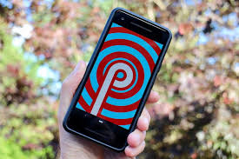

Android 9.0 pie

**ADVANTAGES OF ANDROID :**

1. Opensource framework:-Since Android OS is open source and it is part of the Open Handset Alliance, most of the leading handset manufacturers in the world have Android phones.
2. Uses of tools are very simple.
3. Availability of Apps:-majority of the apps in Google Play are free as compared to the paid apps on iPhone.
4. Inbuilt support for the Flash.
5. Great social networking integration.
6. Integrated Applications & Features: - E.g. : Android allows an option to share, after taking a photo with the Camera.
7. Free to customizes: -You can customize widgets as you wish to.
8. Better Notification System(comprises emails, updates from various widgets.
9. Updated user interface design

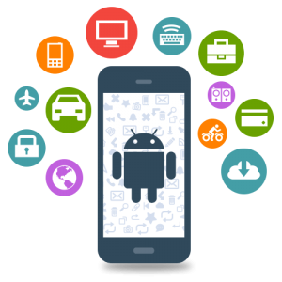

**NUMBER OF USERS IN THE WORLD**

Android is a ludicrously popular operating system, there are more than two and a half billion active android devices around the world today.

Those 2.5 billion devices were produced by more than 180 hardware manufacturers, and they’re not all smart phones. the number also encompasses just about any device with google assistant built in, including smart speakers, smart display’s, and even kaios phones.

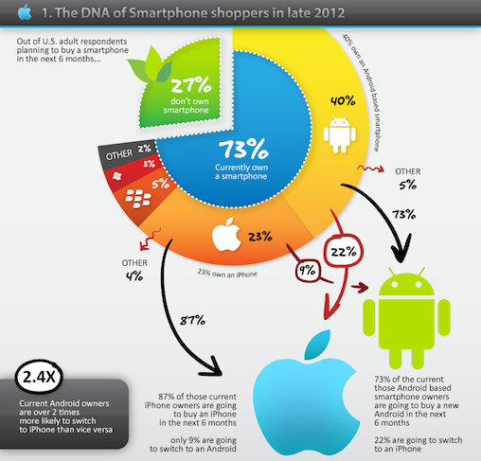

In the above pie chart android os has the most number of users in the world

73% currently uses the mobile in the world in that40% of the mobile users os is android this shows the number of users are more for android than the any other os.

**TYPE OF APPLICATION FOR LIBRARY MANAGEMENT :**



* Handy library is a library management system application for android which is used to manage a personal book collection or a home library.
* It is used to build a small public library , a class library, a church library etc…….
* We can also manage our own wish list
* We can keep track of books that you lend to or borrow from your friends and notify when a book is overdue
* Organizing books by shelves or categories.
* This application supports 18 languages: Arabic, Chinese,English,French,german,Greek,hindi,Indonesian,Italian,Japanese,

polish, Portuguese,russian,Spanish,Turkish,thai,Romanian and viatnamese.

**ER-DIAGRAM :**

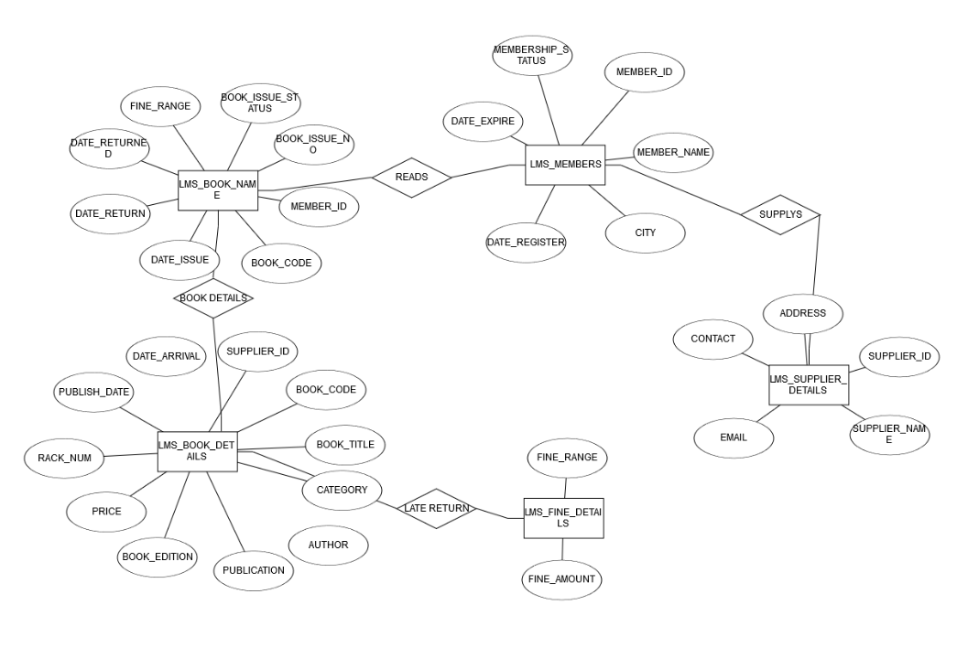

In the above ER diagram the entities are :1) lms_book_name

2) lms_members

3) lms_supplier_details

4) lms_book_details

5) lms_fine_details

QUERIES ON THE ABOVE TABLE:

**1.**write a query to display the member id, member name, city and membership status who are all having life time membership. Life time membership status is “Permanent”

**ANS :** select member_id,member_name,city,membership_status from LMS_MEMBERS where membership_status=’permanent’.

**2.**Write a query to display the book code,publication, price and supplier name of the book which is taken frequently

**ANS :** select b1.book_code,b2.publication,b2.price,b3.supplier_name from(select b1.book_code from LMS_BOOK_ISSUE b1 GROUP BY book_code having count(b1.BOOK_CODE)>1)b1

join LMS_BOOK_DETAILS b2 ON b1.bookcode=b2.book_code

join LMS_SUPPLIERS_DETAILS b3 ON b2.supplier_id=b3.supplier_id

**3.**Write a query to display the member id,member name who have taken the book with code ‘BL000002’.

**ANS :** select b1.member_id,b1.member_name,b2.book_code from LMS_MEMBERS b1,LMS_BOOK_ISSUE b2 where b2.BOOK_CODE=’BL000002’

**4.**Write a query to display the book code, book title and author of the books whose author name begins with ‘p’.

**ANS :** select book_code,book_title,author from LMS_BOOK_DETAILS where AUTHOR like ‘P%’

**5.**Write a query to display the total number of java books available in library with alias name ‘NO_OF_BOOKS’.

**ANS :** select COUNT(category)as NO_OF_BOOKS from LMS_BOOK_DETAILS where CATEGORY=’JAVA’

**6.**Write a query to list the category and number of books in each category with alias name ‘NO_OF_BOOKS’.

**ANS :** select category, COUNT(category)as NO_OF_BOOKS from LMS_BOOK_DETAILS group by CATEGORY

**7.**Write a query to display the number of books published by “prentice hall” with the alias name “NO_OF_BOOKS”.

**ANS :** select COUNT(publication) as NO_OF_BOOKS from LMS_BOOK_DETAILS where PUBLICATION=’prentice hall’

**8.**Write a query to display the member id, member name ,date of registration, membership status of the members who registered before “MARCH 2012” and membership status is “temporary”.

**ANS:** selectmemberid,member_name,DATE_REGISTER,MEMBERSHIP_STATUS from LMS_MEMBERS where DATE_REGISTER<’2012-03-01’ and MEMBERSHIP_STATUS=’temporary’.

**9.**Write a query to display the supplier id ,supplier name and email of the suppliers who are all having Gmail account.

**ANS :** select supplier_id, SUPPLIER_NAME,EMAIL from LMS_SUPPLIERS_DETAILS where EMAIL like ‘%gmail.com’

**10.**Write query to display the average price of the books which is belonging to ‘JAVA’ category with alias name “AVERAGEPRICE”.

**ANS :** select AVG(price) as ‘AVERAGEPRICE’ from LMS_BOOK_DETAILS where CATEGORY=’java’.

**TOPOLOGY**

**Types of topology**

There are 4 main network topologies

1. Star network topology
2. Bus network topology
3. Ring network topology
4. Mesh network topology

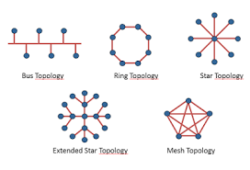

**TOPOLOGY FOR MANAGING THE BOOKS IN LIBRARY :**

The best topology for managing books in a library would be the bus topology.

**BUS TOPOLOGY :**

Bus topology is one of the common network setups. In this configuration each and every computer is connected to a single cable or backbone. A network cable is used to connect them together. A bus topology consists of main run cable with terminator at each end .all nodes like workstations ,printers ,laptops,servers etc., are connected to the linear cable. The terminator is used to absorb the signal when the signal reaches the end, preventing signal bounce.

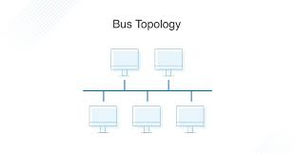

**ADVANTAGES OF BUS TOPOLOGY :**

* It is easy to connect to a device to the network.
* It is cheaper than other network options.
* The failure of one station does not affect the rest of the network.
* No hubs or switches are required
* Extensions can be made to the network.
* Multiple nodes can be installed without difficulty.
* Multiple peripherals can be supported through bus topology.
* Wiring terminators take no power requirements.

**WHY BUS TOPOLOGY?**

Among the four topologies we choose the bus topology for our project for presenting the books management in the library because our plan is to execute the program which should collect the book details , renewal, return date etc…It would be easy as all the devices can be connected to this network in addition to computers. this can increase the speed of productivity because instead of sending commands to a central network , a command can be sent directly to the needed peripheral .and with bus topology the network allows data to flow freely through out the network so the output for the given input will come fast.

**SUMMARY**

**IMPORTANT FEAUTRES OF OUR SYSTEM**

• Keep record of different categories like; Books, Journals, Newspapers, Magazines, etc.

• Classify the books subject wise.

• Easy way to enter new books.

• Keep record of complete information of a book like; Book name, Author name, Publisher’s name, Date/ Year of publication, Cost of the book, Book purchasing date/ Bill no.

• Easy way to make a check-out.

• Easy way to make a check-in.

• Automatic fine calculation for late returns.

• Different criteria for searching a book.

• Different kind of reports like; total no. of books, no. of issued books, no. of journals, etc.

• Easy way to know how many books are issued to a particular student.

• Easy way to know the status of a book.

• Event calendar for librarian to remember their dates.

• My Notes section for librarian to write any note.

• Online access for registered user to see the status of their books.

• No need to invest heavily on Hardware.

• SAAS based pricing.

**Who will use this?**

* This application is mainly useful for library. We can easily find the book details ,supplier details, registered use details etc……,this application can be used by the university libraries mostly to manage their daily reports of each and every transaction which will be made in the library.
* And our application is also useful to public libraries and online libraries for the people who are interested to read books.
* It will be used in institutions as a institutional management ,it will focus on specific issues by libraries and library management professionals.it will encompasses normal managerial tasks as well as intellectual freedom and fundraising responsibilities.
* In library for the automation of the day to day processes which will increase the productivity ,it will saves time , it enhances the presentation of the library ,it will increase efficiency so by using this in library or in a institution it will increase the comfort and enjoyment of the librarians nd also the library users.

**MARKETING METHODS :**

POSTERS: it is a very effective marketing tool ,even today’s digital society. By putting posters in places that may seem little different but it will give a nice promotion.

TARGETED EMAILS: send out targeted emails to the group will try to attract with specific products or services. Email subject lines should be interesting and catchy to ensure they get opened. We should use simple language and should include the library details and directions.nd should include link to open the website easily.

E-NEWSLETTERS: it is also a best way to marketing about the library management system .now a days e-news letters are red by so many people so it is sure that marketing can be done easily by this method.

TRAINING: The trick to effective marketing is identifying the groups that most need to hear your message and tailoring your message specifically to these people. Once you have identified your targets,

INFO PACKETS: This is the perfect time to get staff members interested in the library since new hires are keen to do well and prove their worth.

MEETING AGENDAS: By speaking to department heads let them. Know you want to demonstrate how library can save money.